


SAP ERP S/4HANA Public Cloud Implementation
For Thai Petroleum Pipeline Co., Ltd
Functional Specification
ZPURE001-Print Purchase Order
Document Version: V1.0
Date: 17.08.2026

Approval Signature: Material Management Functional Specification

Thai Petroleum Pipeline Co., Ltd

Approved by: Khun Woranan Tanthiptham  Position: Procurement & Contract Manager  Business Process Owner: MM-PU  Approved Date: |  |  | Approved by: Khun Sirichai Chonbordeechalermroong  Position: Corporate Support Dept. Manager  Business Process Owner: MM-PU  Approved Date:
Approved by: Khun Tagon Thewarangsee
Position: Information System Manager
Business Process Owner: Project Manager
Approved Date:

Document Change Control
This section provides control for the development and distribution of revisions to the Project Charter up to the point of approval. The Project Charter does not change throughout the project life cycle, but rather is developed at the beginning of the project (immediately following project initiation approval, and in the earliest stages of project planning). The Project Charter provides an ongoing reference for all project stakeholders. The table below includes the revision number (defined within your Documentation Plan Outline), the date of update/issue, the author responsible for the changes, and a brief description of the context and/or scope of the changes in that revision.

Revision Number | Date of Issue | Author(s) | Brief Description of Change
V1.0 | 17.08.2026 | Phutachon Aumarit | Initial Document

Table of Contents
1. Development Summary 5
2. Functional Requirements 6
2.1 Authorization 6
2.2 Prerequisites / Assumptions 6
2.3 Detail Program Logic 6
2.4 Conditions 7
2.5 Path Print Output Form 10
2.6 Output Screen 12
3. Testing 13
4. Appendix 13

Development Summary
Object ID | ZPURE001
Object Name | Print Purchase Order
Program Name | Print Purchase Order
Existing program related (If any)
Module | MMPU
Estimated MDs
Menu Path
FRICEW Type | ☐ Workflow  ☐ Report  ☐ Interface  ☐ Conversion  ☒ Enhancement  ☐ Form | Complexity | ☐ Very High  ☐ High  ☒ Medium  ☐ Low
Statutory | ☐ Yes ☒ No | Frequency | Daily
Processing type | ☒ Online  ☐ Background | Schedule Job | ☒ No  ☐ Yes, (Please define)
Transaction Code | - | Develop By | R2 Development Team
Requested by | Procurement Team | Request Date | 08.07.2026

Functional Requirements

2.1 Authorization

No | Role | Remark
1 | หน่วยงานจัดซื้อ | Role: Procurement

2.2 Prerequisites / Assumptions

No | Description | Remark
1 | สร้าง Custom Program Print Form PO
2 | ผูกเงื่อนไขจาก Table : PO
3 | สร้าง Setting View
4 | Adobe Form ใหม่ ตามเงื่อนไขการแสดงข้อมูลของ Thappline
5 | Output Type กับ Application เพื่อใช้งาน

2.3 Detail Program Logic

No | Program Logic | Remark
1 | Join Table & Field each Table | ดึงข้อมูลจาก Table หลังบ้านเพื่อนำค่าแต่ละ Field มาแสดงผล
2 | Z Output Type for PO Form | สร้าง Output Type ใหม่ สำหรับผูกเงื่อนไข PO Form
3 | Copy Std. Adobe Form to Custom Form | Copy PO Form Std. เพื่อมาทำ Form ใหม่

ตัวอย่างโปรแกรม Print Purchase Order

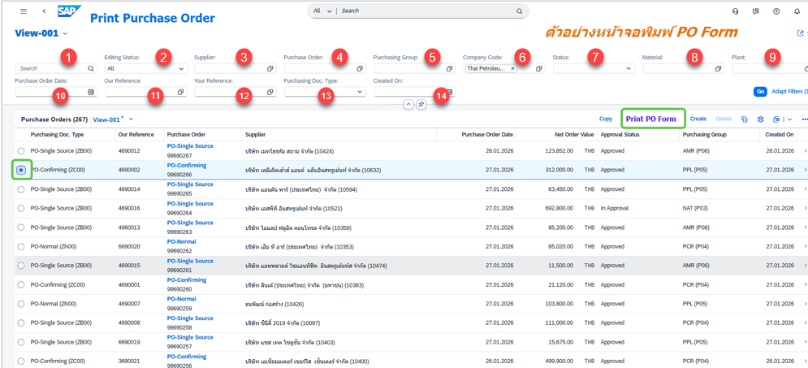

2.4 Conditions
ข้อมูลโปรแกรม Print Purchase Order (Header)

No | Label Text | Application | Field Name | Detail Description
1 | Search | Manage Purchase Order (Header) | Search | ดึงจาก Manage Purchase order>Search
2 | Editing Status | Manage Purchase Order (Header) | Editing Status | ดึงจาก Manage Purchase order> Editing Status
3 | Supplier | Manage Purchase Order (Header) | Supplier | ดึงจาก Manage Purchase order> Supplier
4 | Purchase Order | Manage Purchase Order (Header) | Purchase Order | ดึงจาก Manage Purchase order> Purchase Order
5 | Purchasing Group | Manage Purchase Order (Header) | Purchasing Group | ดึงจาก Manage Purchase order> Purchasing Group
6 | Company Code | Manage Purchase Order (Header) | Company Code | ดึงจาก Manage Purchase order> Company Code
7 | Status | Manage Purchase Order (Header) | Status | ดึงจาก Manage Purchase order> Status
8 | Material | Manage Purchase Order (Header) | Material | ดึงจาก Manage Purchase order> Material
9 | Plant | Manage Purchase Order (Header) | Plant | ดึงจาก Manage Purchase order> Plant
10 | Purchase Order Date | Manage Purchase Order (Header) | Purchase Order Date | ดึงจาก Manage Purchase order> Purchase Order Date
11 | Our Reference | Manage Purchase Order (Header) | Our Reference | ดึงจาก Manage Purchase order> Our Reference
12 | Your Reference | Manage Purchase Order (Header) | Your Reference | ดึงจาก Manage Purchase order> Your Reference
13 | Purchasing Doc. Type | Manage Purchase Order (Header) | Purchasing Doc. Type | ดึงจาก Manage Purchase order> Purchasing Doc. Type
14 | Create On | Manage Purchase Order (Header) | Create On | ดึงจาก Manage Purchase order> Create On

ข้อมูลโปรแกรม Print Purchase Order (Line)

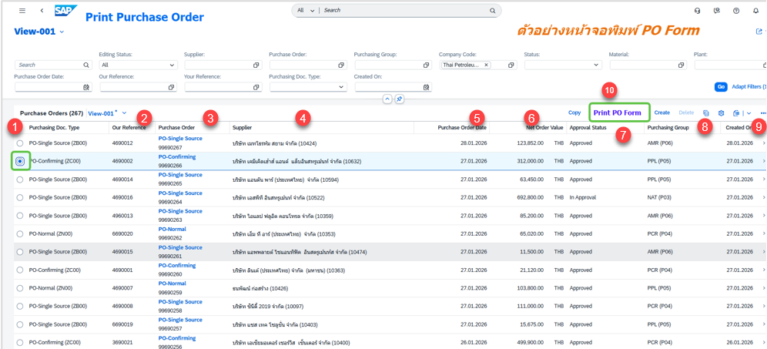

No | Label Text | Application | Field Name | Detail Description
1 | Purchasing Doc. Type | Manage Purchase Order (Line) | Purchasing Doc. Type | ดึงจาก Manage Purchase order> Purchasing Doc. Type
2 | Our Reference | Manage Purchase Order (Line) | Our Reference | ดึงจาก Manage Purchase order> Our Reference
3 | Purchase Order | Manage Purchase Order (Line) | Purchase Order | ดึงจาก Manage Purchase order> Purchase Order
4 | Supplier | Manage Purchase Order (Line) | Supplier | ดึงจาก Manage Purchase order> Supplier
5 | Purchase Order Date | Manage Purchase Order (Line) | Purchase Order Date | ดึงจาก Manage Purchase order> Purchase Order Date
6 | Net Order Value | Manage Purchase Order (Line) | Net Order Value | ดึงจาก Manage Purchase order> Net Order Value
7 | Approve Status | Manage Purchase Order (Line) | Approve Status | ดึงจาก Manage Purchase order> Approve Status
8 | Purchasing Group | Manage Purchase Order (Line) | Purchasing Group | ดึงจาก Manage Purchase order> Purchasing Group
9 | Create On | Manage Purchase Order (Line) | Create On | ดึงจาก Manage Purchase order> Create On
10 | ปุ่ม Print PO Form | - | - | สร้างปุ่ม Print Purchase Order สำหรับพิมพ์เอกสารใบสั่งซื้อ

2.5 Path Print Output Form

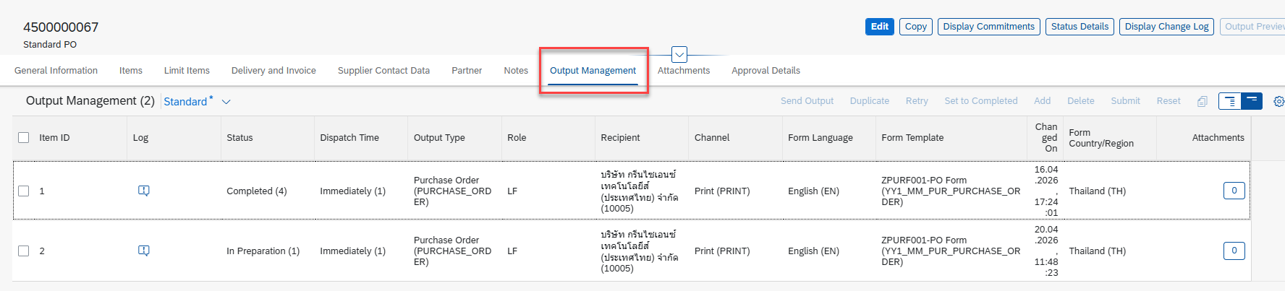
ตัวอย่าง Form Std.
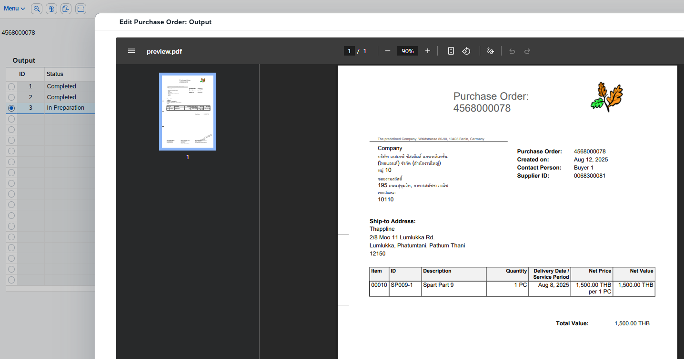

2.6 Output Screen
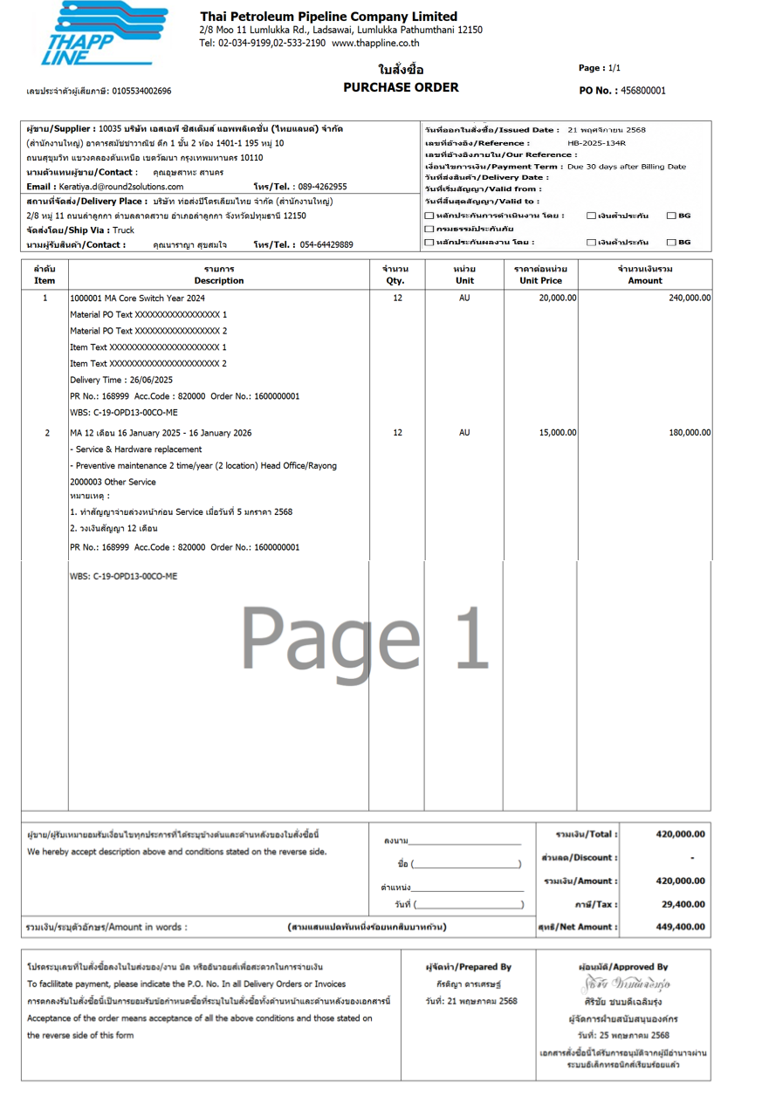

Testing

No. | Description | Expected Result
1. | ทำการ Filter รายละเอียดต่างๆที่หน้าจอ Print Purchase Order | สามารถแสดงข้อมูลตาม Filter ได้อย่างถูกต้องและครบถ้วนทั้งหมด
2. | กดพิมพ์เอกสาร Purchase Order จากหน้าจอ | สามารถแสดงเอกสาร Purchase Order เมื่อมีการกดปุ่ม Print PO Form
3. | รายละเอียดของเอกสาร | แสดงรายละเอียดต่างๆในเอกสารได้ถูกต้องและครบถ้วน

Appendix
N/A

